2020 Baseball Free Baseball Camp

Spring is just around the corner, and it’s time to play ball !!!
Please remind/notify your friends and neighbors about the upcoming Camp
Visit our website for online registration to play Spring Run Baseball http://www.springrunaa.org
News on Facebook/Instagram: Spring Run Huskies & Spring Run Athletic Association

DATES: TIMES: LOCATION:
Saturday February 29th 2PM-6PM Iron Bridge Sport Complex
Ages 4-6 2pm-3pm 11400 Iron Bridge Rd, Chester, VA 23831
Ages 7-10 3:15pm-4:15pm
Ages 11+ 4:30pm – 6pm

Note: All new players must be registered to participate. If you want to register, please go online to register or bring the paperwork and payment to the camp.

ELIGIBILITY: Baseball - Ages 4 – 18 as of August 31st, 2020

REGISTRATION Baseball - $100 per player Ages (4-6) & $150 all ages over 7 ($10 family discount each additional child) ($15 service charge for all paper applications)
FEES: Payment is required at the time of registration
(cash, check, or card made payable to SRAA)
MEMBERSHIP $50.00 per family for the first year / Renewal $20.00 per family per year thereafter
FEES: Note: SRAA membership year is July 1st to June 30th

QUESTIONS: Baseball –Adam Queen 804-393-8013 or email: springrunbaseball@gmail.com
We look forward to seeing everyone back on the field this season. Please visit our website for more information & the latest happenings at SRAA…http://www.springrunaa.org/

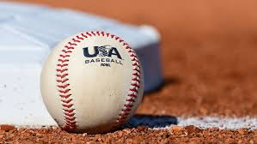   BBC or approved bats only!

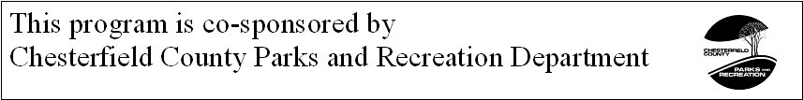
Please make sure you complete the required forms for your sport prior to registration. Please visit our “Forms” page, locate your sport and then click on the blue link to open and fill out the required forms.

